New pet welfare fund for rescue organisations launching in January

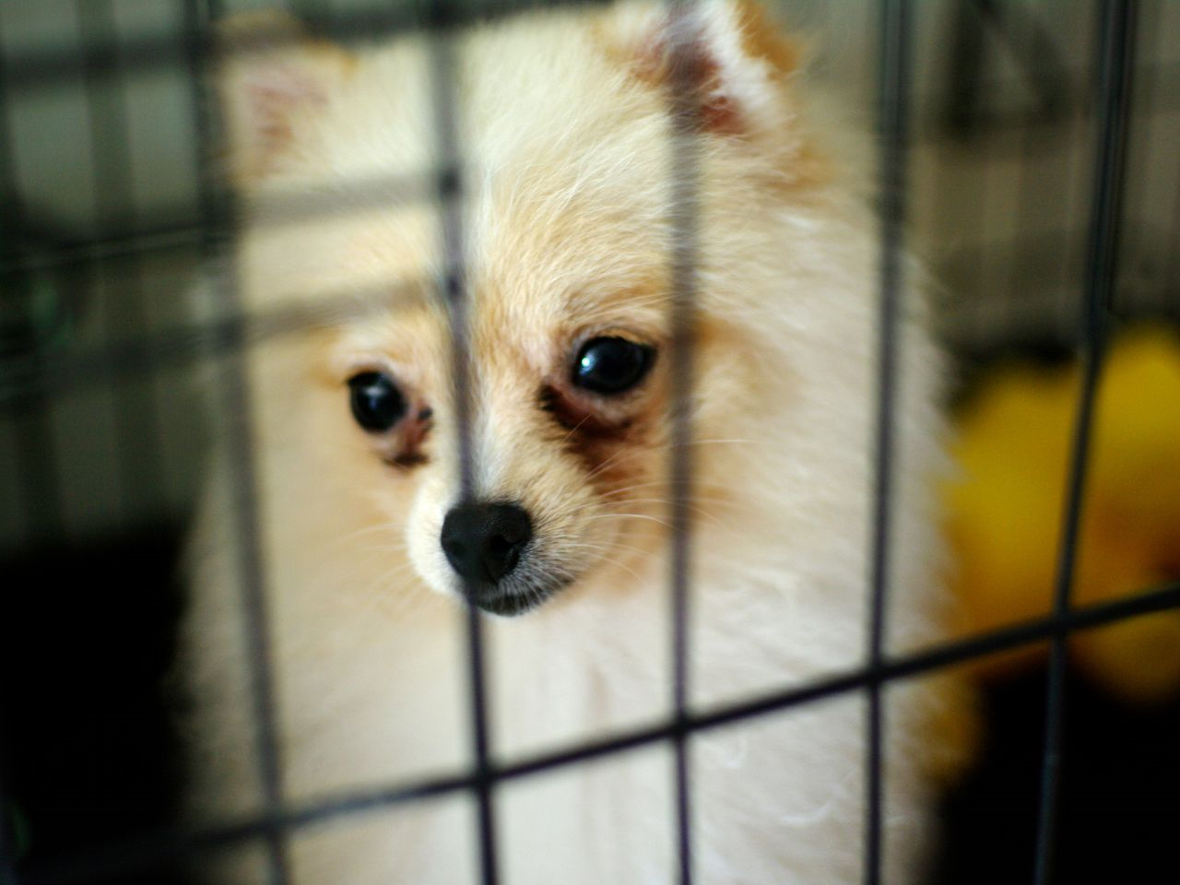

Animal welfare charity, Naturewatch Foundation, is launching a new Pet Rescue Grant in 2024 to help dogs, cats and rabbits impacted by illegal breeding and selling.

At least £5,000 will be awarded to UK charities and community interest companies (CICs) annually to help support the rescue and rehabilitation of animals who have been exploited by the illicit pet trade.

More than half of UK households own a pet, and its thought as many as 50% of puppies are supplied by illegal sources. Low-welfare breeding has a devasting impact on animal welfare and owners, and the illicit pet trade has increasingly attracted the involvement of organised criminals.

Naturewatch Foundation campaigns for better pet welfare protections and investigates tip-offs from the public about the illegal pet trade. The charity is launching the grant at a time when the animal rescue sector is facing unprecedented challenges caused by the cost-of-living crisis and rising abandonments following the boom in pet ownership during the Covid pandemic.

Natalie Harney from the charity said, “As an animal-loving nation, it’s a tragedy that so many of our beloved pets are the product of the illicit pet trade. We’ve been campaigning and investigating to end illegal breeding for years, but we know that without the rescue sector, many abused and exploited pets simply wouldn’t get the loving care and specialist support they deserve. Our new Pet Rescue Grant is our small way of helping those selfless organisations that pick up the pieces.”

Naturewatch Foundation is inviting animal-lovers to get involved by telling them about deserving rescue organisations that could benefit from the grant at action.naturewatch.org/your-favourite-rescue.

Rescue organisations that are interested in applying can visit naturewatch.org/petrescuegrant or email petrescuegrant@naturewatch.org to find out more. Applications open on 24th January 2024 and close on 21st February 2024.

END

For further information please contact:

Natalie Harney
Campaign Manager, Naturewatch Foundation
petrescuegrant@naturewatch.org
+44 (0) 1242 252 871

About Naturewatch Foundation

Naturewatch Foundation is a registered charity that has been speaking out on behalf of animals for 30 years by:

- Campaigning peacefully against animal abuse;
- Lobbying to improve animal protection legislation;
- Raising awareness through education;
- Supporting the World Animal Day movement to raise the status of animals around the globe.

The charity’s mission is to advance animal welfare standards and end animal cruelty.

Visit naturewatch.org.

