For immediate release:

Jackery’s Solar and Portable Energy Products Receive Carbon Footprint Verification from TÜV SÜD – an Industry First

London, UK, 13 June 2023 / -- Jackery has announced it has received carbon footprint verification from TÜV SÜD, an internationally recognized third-party certification organisation, for two solar panel products and seven portable power products, which is a first for the solar generator industry.

The carbon footprint results of Jackery's products have been stated and have achieved the international standard ISO 14067:2018, a standard that defines the requirements necessary for organisations to qualify the carbon footprint of their products. The main goal of this ISO is to determine the greenhouse gas emissions produced during each stage in the life cycle of a product.
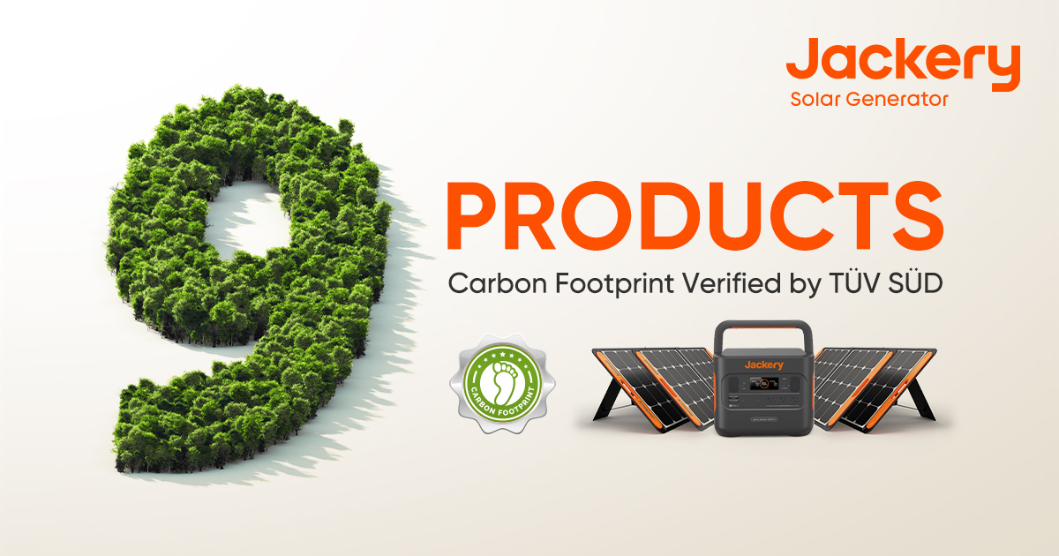

With the continuous introduction of carbon footprint disclosure policies, there is an increase in awareness and attention to renewable energy sources across a variety of industries and sectors. The transformation and upgrading of portable power products and their deeper commitment to sustainable development have become more important. As a global leader in the portable power industry, Jackery not only meets power demand for outdoor and home scenarios but in collaboration with TÜV SÜD, can now offer peace of mind that carbon footprint verification for its Jackery solar panels and portable power products has been achieved.
(1/2)

Jackery established its relationship with TÜV SÜD in August 2022 when TÜV SÜD certified the world's first consumer-grade photovoltaic products for Jackery. In this cooperation, experts from the sustainability team of TÜV SÜD Product Service Division conducted carbon footprint verification of Jackery SolarSaga 80W and 100W solar panels, as well as seven models of Jackery portable power stations (500, 708, 1000, 1500, 800 Pro, 1000 Pro, 2000 Pro), evaluating the greenhouse gas emissions from the acquisition of raw materials to disposal throughout the lifecycle of the products. TÜV SÜD confirmed that the carbon footprints of the products complied with the requirements of ISO 14067:2018 International Standard "Greenhouse gases - Carbon footprint of products - Requirements and guidelines for quantification" and issued the Carbon Footprint Verification Statement for Jackery's products.

Through this collaboration, Jackery has effectively enhanced the "green competitiveness" of its portable power products in the international market. The authoritative verification from TÜV SÜD also helps further establish Jackery's products as a globally trusted green energy brand, enabling them to embrace the challenges and opportunities of the "carbon neutrality" era from an international corporate perspective.

-ends-

For all media enquiries, image requests and product reviews, please contact: Nicola Cutler, Senior PR UK/Europe nicola@jackery.com or call +44(0)7395 603007

Notes to editors
About Jackery
Jackery, the world's leading innovative portable power and green outdoor energy solution provider founded in California in 2012, is a global top-selling solar generator brand born with a mission to offer green energy to everyone, everywhere. Expanding its footprint from the US to Europe, Japan, and China, Jackery has sold over 3 million units globally since 2018, with its products consistently selected as Best Sellers on Amazon. In addition, Jackery has earned 363 global patents. The brand has so far received 53 prestigious international design awards, including the Red Dot Design Award, the iF Design Award, the A' Design Award and Competition, the Best of IFA Award and the CES Innovation Award. Jackery is also proud to announce its official partnership with IRC, International Rescue Committee, helping those affected by disaster across the globe at their time of need. So far, the carbon emissions reduced by the accumulative globally sold solar panels equals planting 2.46 million trees.

About TÜV SÜD
Founded in 1866 as a steam boiler inspection association, the TÜV SÜD Group has evolved into a global enterprise. More than 26,000 employees work at over 1.000 locations in about 50 countries to continually improve technology, systems, and expertise. They contribute significantly to making technical innovations such as Industry 4.0, autonomous driving, and renewable energy safe and reliable.
(2/2)

