PRESS RELEASE
Let’s get our doctors and nurses thinking differently! Oct 7th launch of proactive healthcare platform
FROM - Health and Wellbeing Trust charity – www.healthelearning.online
CONTACT FOR INTERVIEWS – Dr Rosy Daniel via PA Ally Vickers
Email - ally.@drrosydaniel.org
Telephone - 07481 616100
RE: On Thursday October 7th at 6pm. the Health and wellbeing Trust charity launches its Health-e-Learning platform as pioneering doctor, Rosy Daniel, helps bridge the gap in medical education and works to promote sustainable healthcare solutions for professionals and the public
Launch date – October 7th, 2021
Eventbrite link for free entry - https://www.eventbrite.co.uk/e/public-launch-of-the-hwt-health-e-learning-platform-tickets-169586908007

STARTS
As lifestyle illnesses reach pandemic proportions that threaten our survival, economic stability and the capacity of the NHS and social care systems to deliver effective treatment and care, most medical, nursing and healthcare professional education is still lacking any content covering effective evidence-based therapies, coaching and self-help approaches for primary and secondary prevention of illness.
It is now proven that lifestyle programmes and self-help approaches that shift people from passive patient into proactive health partnerships can prevent and reverse obesity, heart disease and type 2 diabetes. American Cardiologist Dr Dean Ornish has proved that his programme saves health insurers $30,000 for newly diagnosed patients and Dr Rosy Daniel has proved that her health coaching programme can reverse Type 2 diabetes, obesity and high blood pressure at a fraction of the cost of medical treatment.
Dr Daniel says:
“Whilst the medical profession remains wedded to pharmaceutical solutions to health problems rather than addressing the cause of these costly illnesses, NHS costs will continue to soar and many lives will be ruined. Let us shift our focus and get our healthcare professionals thinking differently about primary and secondary prevention of illness with cheap, sustainable natural healthcare approaches that empower people, improve health and quality of life and save costs.’
Her starting place is to offer short vocational training courses online that will meet the Continuing Professional Development requirements for Health care Professionals, give them new perspectives and skills and inspire them to focus future health services on the regeneration of health as well as teaching them healthy self-care to prevent burnout in their hugely demanding roles.
ENDS

Background Information:
The Health and Wellbeing Trust
The Health and Wellbeing Trust is a Bath based charity which provides online, vocational training and self-help information for healthcare professionals, complementary therapists and the public alike. Its goals are to promote engagement in proactive, sustainable healthcare solutions for the 21st century, to help prevent and reverse lifestyle illness, reduce the strain on the NHS and promote whole-hearted health and full potential living by enabling people to:
- Learn sustainable, affordable, evidence-based methods that can help to reverse lifestyle illness and promote health
- Broaden their understanding of a proactive approach to healthcare and self-help
- Build their knowledge of regenerative healthcare and its many benefits

The website and Health-e-Learning platform showcases the catalogue of 10 hour Discovery Courses developed in collaboration with some of the world’s most inspiring teachers of holistic health and environmental theory and practice. CPD credits are awarded by their International College of Regenerative Health. These courses have been developed by teachers who specialise in the fields of:
- Integrative Medicine and Regenerative Health
- Mind and Spirit
- Models and Methods within Natural Healthcare
- Complementary Therapies and Self-Help
In addition to the Health-e-Learning platform, the charity has developed a Health-e-Information platform, providing the latest news, science and developments within the fields of health and wellbeing. Also, a comprehensive natural health Resource Directory connecting people with hundreds of lead bodies and professional associations, as well as further training offered across the many complementary therapies, psycho-spiritual, self-help, and environmental organisations.

Dr Rosy Daniel BSc MBBCh
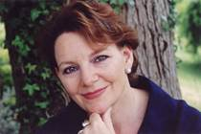
Rosy has been leading developments in natural healthcare for three decades, first as Medical Director of the Bristol Cancer Help Centre (Now Penny Brohn UK), then as founder of Health Creation Coaching and Consultancy and now as Project Leader of the Health and Wellbeing Trust. Her goal is to create a permanent resource for doctors, nurses and healthcare professionals wishing to broaden their education and learn about natural, sustainable, responsible healthcare solutions. Rosy:
- Runs her holistic health clinic where she guides the regeneration of positive health for those with cancer, heart disease, diabetes, depression, obesity, arthritis and stress-related illness.
- Practiced at the Harley Street Oncology Centre, London (1999-2004) supporting Professor Karol Sikora, the Oncology team and their patients.
- Trained medically in Cardiff (1977-1983) and achieving a First-Class Physiology degree (1980), she then trained as a General Practitioner in Bristol (1986-1989).
- From 1990 to 1999 she was doctor then Medical Director of the Bristol Cancer Help Centre (now Penny Brohn Cancer Care) winning the Patronage of His Royal Highness the Price of Wales in 1997. After leaving the Bristol Centre she set up Health Creation, offering training in Holistic Health Coaching and Consultancy for individuals and in the workplace.
- In 2009, the five Health Creation training modules developed by Rosy were incorporated into the Professional Masters Programme Mentoring and Coaching Award at Bath Spa University. Health Creation has associates in Switzerland, Egypt, the USA, Ireland, China, Hong Kong and Australia and is set to go global through the creation of its digital health coaching tools and webinar training.
- In 2007 Dr Daniel became Medical Director of the Health and Wellbeing Trust charity, through which she co-founded the International College of Regenerative Health (ICRH), to train doctors and nurses in Integrative Medicine.
- Dr Daniel is a passionate advocate for positive health and environmental protection through the promotion of full potential living based upon developing emotional, physical, spiritual and ecological intelligence and integrity.
- She is a Patron of the British Wheel of Yoga and the Healing Trust and dedicated health activist, working determinedly to promote healthy change for a sustainable future for people and planet.
Website - www.drrosydaniel.org
Email – rosy.daniel@healthcreation.co.uk

Dr Dean Ornish
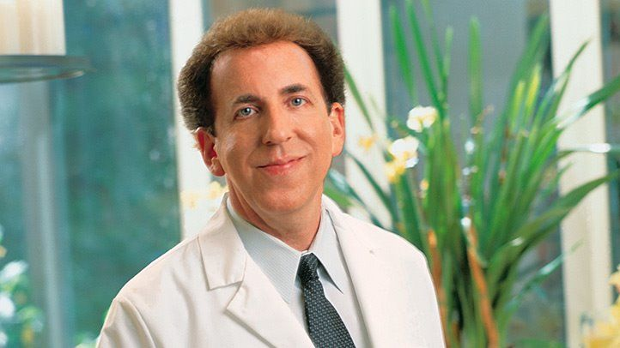
Dean is a ground-breaking American Cardiologist who proved in 1998 that coronary artery disease could be revered through lifestyle programmes. He is Founder of The Preventative Medicine Research Institute (PMRI) a non-profit public organisation who are dedicated to providing the highest quality scientific research and education, evaluating and teaching the power of lifestyle medicine based on the four pillars - 'eat well, move more, stress less, love more’ now proven to reverse and prevent the progression of the most common, costly, and debilitating chronic diseases. PMRI’s research uses the latest in high-tech medical technologies to prove the power of these low-tech lifestyle changes.
Scientists at PMRI were the first to prove that these lifestyle changes can reverse the progression of even severe coronary heart disease, type 2 diabetes, early-stage prostate cancer, hypertension, hypercholesterolemia, and other chronic diseases.
Dr. Ornish’s lifestyle medicine program was the first to receive Medicare coverage and is also reimbursed by many of the major insurance companies at hospitals, clinics, and physician groups nationwide. They are achieving bigger changes in lifestyle, better clinical outcomes, larger cost savings, and higher adherence than have ever been accomplished. www.pmri.org

