The brand shaking up the sexual health market
No gimmicks, no shame, no fuss

Sales of HANX condoms soared over the weekend as self-isolating
couples hunker down to some hanky panky*.

HANX condoms are gynaecologist approved and come in stylish and discreet packaging, sparing blushes at the checkout.

They are also available to purchase through an innovative monthly subscription, so sign up to stay safe even when supermarket stocks run low.

HANX founders Dr Sarah Welsh and financier Farah Kabir are on a mission to stamp out the stigma associated with buying condoms and lubricants.

HANX presents a new kind of condom brand, speaking directly to women with a neutral, stylish design that eradicates the stigma of purchasing and carrying condoms. With its classy packaging HANX is set to become a cult handbag item.

Designed to optimize the sexual health and pleasure, HANX condoms are
ultra-thin and silky-soft for maximum sensitivity. The condoms are made using vegan certified, 100% natural and fair-trade latex to be kind to our bodies whether those bodies are male, female or non-binary.

The products have a pH that won’t cause irritation or disturb the delicate balance of healthy vaginal flora leaving women more likely to contract thrush or vaginal infections such as bacterial vaginosis.

Unlike so many condoms on the shelves (which are processed using the milk protein casein, or other condoms which made from lamb intestines),
HANX condoms are 100% vegan.

HANX condoms come in stylish matte foil packaging presented in a discreet, gender-neutral white box, slim enough to tuck into your bag or purse.

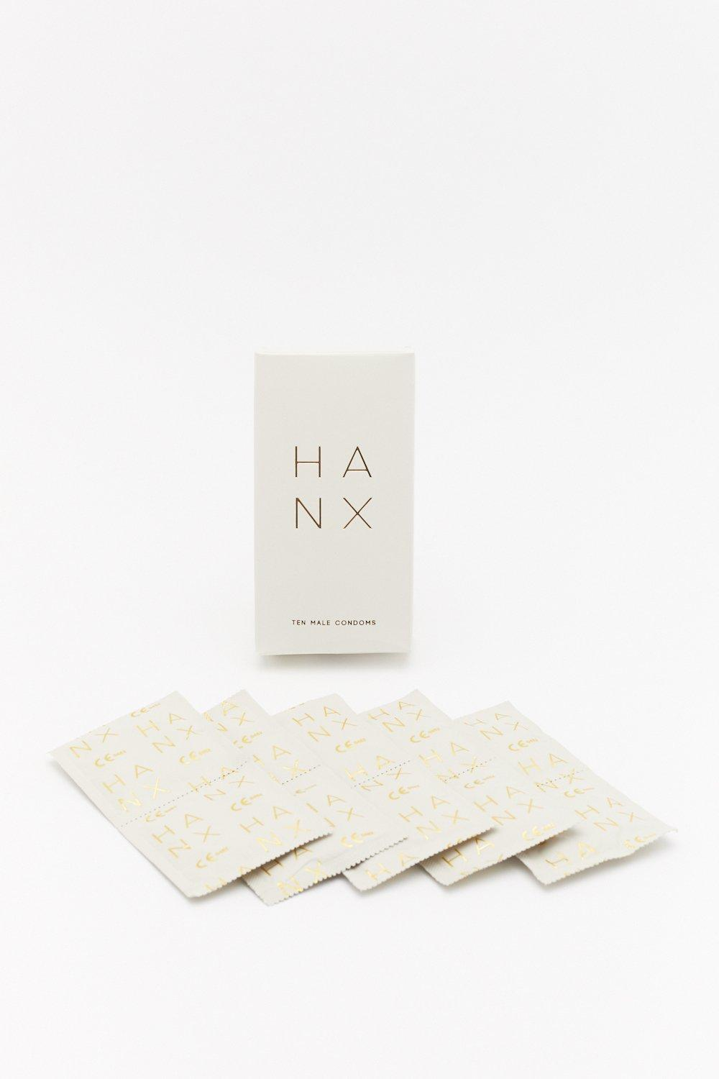
HANX LUBRICANT & HANX TEN PACK OF CONDOMS

HANX condoms are priced at £4.99 for a box of three and £14.99 for a box of ten. HANX 50ml lubricant £14.99

HANX is available to purchase from Boots, Nasty Gal, Coco De Mer, Glow Bar, Missguided, Farmdrop & Amazon and on line at hanx.co.uk.

Subscription boxes also available on line at hanx.co.uk
Saving 15% off the RRP and qualifying for free shipping.
Prices from £4.24 ~ 3 pack

To find out more go to hanx.co.uk.
Instagram @hanxofficial, Twitter @hanx_official and Facebook at @hanxofficial

For more information, founder quotes and comment or samples, please contact The Karen Berman Consultancy
E: karen@karenberman.uk.com
T: 020 8420 7306; M: 07725 543142

NOTE TO EDITORS:
INFORMATION ABOUT CO FOUNDERS – both are available for comment

FARAH KABIR ~ A registered chartered accountant. Farah began her career in investment banking before focusing her talents on building a considered sexual wellness brand that puts people first. She is smashing taboos around sex, pleasure and health. Whilst empowering people to own their sexuality

Dr. SARAH WELSH ~ a gynaecology doctor ~ she spent the early years of her career looking after women from their first period to their first child, and continues to work as a gynaecology doctor from time to time. Sarah now focusses her talents on building a considered sexual wellness brand that put people first. Her experience in sexual health clinics and obstetrics/gynaecology ensure HANX products are medically approved and kind to our bodies, as well as being safe.

