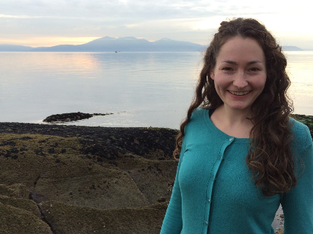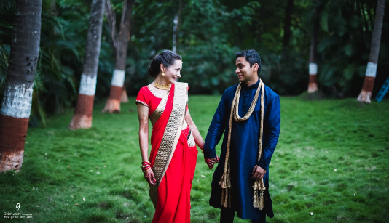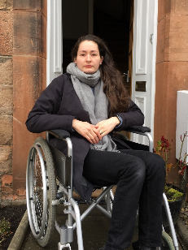

Kim Gurav
Kim is one of the volunteer organisers for MEAction Scotland – she describes at the end of the case study why she has decided to use her very limited energy to advocate for people with ME.
I'm 34 years old and have had ME for around two to three years, maybe longer. It took 18 months to get doctors to take me seriously enough to investigate a diagnosis. I was told by one GP that even if I did get a diagnosis for ME it wouldn't help me much! She couldn't have been more wrong. An early diagnosis could have prevented me from deteriorating. I would not have lost most of my life if I'd had any of the information and resources to combat and understand, and most importantly manage ME.
I've lived in Edinburgh about 7 years, and I'm from West Kilbride in Ayrshire originally. I'm 34 and I've been married for a year and a half. I used to work in HR at Edinburgh University until my health declined.
I now have severe ME, I'm in the 25% category - around a quarter of people with ME are severe. When I got the diagnosis last summer I would have had mild or moderate ME. This meant I couldn't work but I had a measure of independence, getting out a few times a week. I still had something of a life. However because my GPs knew so little about ME, and because the referral to the local ME service took around six months I had no support or advice whatsoever. Even when I did finally attend the local ME service (made up of Occupational Therapists and Psychologists not Neurologists or immunologists - ME is a neuro-immune condition) it was so limited and the appointments so infrequent that I declined badly in that time.
I am now housebound. I can't leave the house without exacerbating my health very badly. My symptoms are severe debilitating fatigue, regular migraines, gastrointestinal issues, food intolerances, orthostatic intolerance, cognitive dysfunction and sleep disturbances etc. I can walk from room to room but not much more than that. I need assistance with all basic tasks, even dressing. I have to spend most of the day resting and lying down. I can read a little, television is too tiring. I can have occasional visitors but not for more than half an hour. I get frequent migraines where light and sound are excruciating.
I had to give up my job and my career - I worked in HR at Edinburgh University until I got ill. I was only just able to get through my wedding in my husband's home country of India last October. For me to manage we had to space the wedding events each a day apart (weddings take about a week in India). When we got back to Scotland after that and moved into our first home together one of the most painful things was realising that we would have to cancel our wedding here in Scotland, due to happen five months later in April. It took me so long to come to terms with that. I didn't get to celebrate getting married with all my Scottish friends and my wider family - only nine of my friends and relatives had been able to come to India. We didn't get to have the wedding I had dreamed of. It was a gutting loss.
So much of the past year has been loss. It's been the most enormous adjustment. Sometimes it feels like I've lost almost everything. It can be very hard to keep going. I've had to learn entirely new ways of coping. I've never faced anything this hard in my life.
I can no longer go out at all. I can't even get to the doctor's surgery for appointments. And the doctors refuse to do home visits for people with ME. This has made it incredibly difficult to get by. I feel entirely abandoned by the system. If I made myself go to the doctors I would make myself incredibly sick, worse than what I experience every day already. And I risk causing myself to decline further. I could become completely bedbound and lose the ability to walk entirely. I am not willing to take that risk. Therefore it's very difficult to get pain medication for migraines for example, or to have any blood tests done. Etc. But even if I did make it to the doctors many GPs misunderstand the illness and treat it as psychological. I have been told by GPs to "get out more", to "exercise". This is completely disastrous for an ME patient – the illness is exercise intolerant. This is not laziness. There is a considerable body of research showing how people with any deteriorate with even minimal physical exertion. To tell us to exercise is like giving sugar to a diabetic person. Even doctors who do recognise it is genuine and a physiological illness simply have no idea what to do – there are no effective treatments and certainly no cure.
Because of the severity of this illness my life has been turned upside down completely. I can't see friends, can't socialise. Isolation is immense. And I'm incredibly fortunate to have fantastic friends who are massively supportive. I've had to miss so much - my cousin's wedding, every one of my nieces and nephews birthdays, nativities, ballets. I can never go to any of my friends dinners or parties.
One of the most incredibly painful losses was that I couldn't visit my terminally ill sister-in-law. Then when she passed away my husband had to fly back to India alone, without me there for support. It was heartbreaking. I didn't get to say goodbye to her. And I didn't get to be at her funeral and have the chance to grieve and be with my family-in-law at such a crucial time. So many many losses.
I don't know where I'd be without my husband. He looks after me full-time on top of his job as a petroleum engineer. (We got married just last October.) He has spent so many hours alongside me learning and researching about ME to help us manage the symptoms, just to get by and survive, given the very limited medical support available.
The Unrest film has given me so much hope, and hope can be in very short supply at times. The story makes me feel validated. Understood. Jen Brea is speaking up on our behalf and through this film telling the story of thousands of us who suffer. And perhaps suffer more than we need to if there was ANY medical support, any genuine understanding. And perhaps treatments could be found if there was proportional research done for an illness which is SO common. Twice as many people have ME than multiple sclerosis! Yet people barely know what it is. The film has provided a really rare opportunity to raise awareness on a very public scale. It's because of this that I got involved and started organising screenings in Edinburgh. I've had to do everything from my bed, composing emails then resting, publicising online, then resting. Small amounts each day because if we as the people with Emmy don't organise this, who will? The whole thing is crowdfunded and organised by local groups. It's not some Hollywood blockbuster. Our screening next week is the third one in Edinburgh and it's sold out. At that we've organised a panel of speakers with a question and answer session afterwards. A few weeks ago we had two screenings at the Cameo, one of which sold out. Along with the Unrest team organisers we've collaborated for a final two screenings in January at the Filmhouse. And I helped with the publicity for the Glasgow team's screening which is again sold out. It's really heartening to see how much demand there is for this film and all the interest. Through this film perceptions of the illness change there is hope that wider change will come.

Why I am involved in campaigning and ME advocacy:
When I got ill it became increasingly apparent that there was virtually no medical care for this illness, and all the GPs I was coming into contact with either had no understanding of ME, or serious misconceptions. And added to that I then found out there was absolutely no funding directed to biomedical research on ME. Unlike any similarly debilitating illness – Multiple Sclerosis etc – there is no research into treatments or a cure. Which is pretty shocking. Especially given how incredibly common this illness is. It's not some rare disease. It affects 21,000 people in Scotland alone. With no publicly-funded research being carried out, it was unbelievable to realise I would have to continue suffering with this severe illness with no hope of change.
It was bad enough coming to terms with having a severely debilitating illness that took away every aspect of my life, that confined me to the house and to daily suffering, but then on top of that find out that I had an illness which is poorly handled by the medical establishment, and widely misunderstood in society. That was an even worse additional blow. At best the situation is shocking neglect, at worst it's sinister.
Because of the terrible situation I saw that the only way things would change is by campaigning and raising awareness. So I got involved with ME advocacy. That first started with organising a series of screenings of the Oscar-shortlisted film Unrest in Edinburgh last autumn and winter. Including a screening of unrest for MSPs at the Scottish Parliament. (Of course I couldn't even attend, being housebound.) I then joined with others in Edinburgh to create a Scottish branch of MEAction - a volunteer-led organisation working for health equality for ME. MEAction Scotland is organising the Millions Missing event here in Edinburgh on the 12th of May on the Mound Precinct. We've also launched a recent petition to the Scottish Government calling for investment in biomedical research. Another part of our work is campaigning to get NHS Education Scotland to review their approach to ME, and improve their training of medical professionals.
To speak to Kim email: kimgurav@gmail.com

