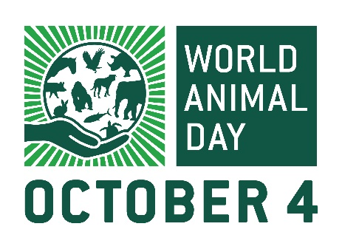
PRESS RELEASE

Date: 31st August 2023
FOR IMMEDIATE RELEASE

UK charity funds animal ambulance for pangolins, orangutans and sun bears in Indonesia
A British animal welfare charity has announced the 2023 winners of their recently increased World Animal Day grant. Jakarta Animal Aid Network (JAAN) in Indonesia will receive much-needed funds from Gloucestershire-based Naturewatch Foundation to purchase a mobile veterinary clinic.
Working as a legal partner to the government, JAAN rescues, rehabilitates and provides veterinary care to stray and wild animals across the country, but does not receive any government funding. They work with animals including pangolins, orangutans and sun bears, as well as dogs and cats. The new van will enable JAAN’s team to reach and treat animals around Bali, Java and Sumatra, by:
- Sterilising large numbers of stray animals in remote areas
- Treating and moving animals confiscated from cruelty cases
- Transporting wildlife between JAAN’s centres on different islands, and
- Releasing rehabilitated animals back into their natural habitats.
Femke Den Haas, Co-founder and Field Coordinator at JAAN, said: “This grant allows us at JAAN to treat animals in areas very isolated and far, who else would have been left to suffer. It allows us to bring rescued animals to safety and treat rescued animals quickly, increasing their survival chances. We are really grateful to be the winners of the World Animal Day grant.”
Two other applicants will receive smaller awards from the enhanced grant this year:
- Cape Animal Welfare Forum in South Africa will run a compassion fatigue workshop for animal welfare workers from their 58 member organisations.
- Swaziland Animal Welfare Society will distribute 10,000 educational leaflets, listing how to properly care for animals, in rural areas where residents have little to no awareness on the issue.
Sarah Carr, CEO of Naturewatch Foundation and coordinator of World Animal Day, said: “The past few years have been difficult for everyone, including charities and those on the front line of animal welfare. So, as the coordinators of World Animal Day, Naturewatch Foundation was excited to double the annual grant to £10,000 this year! Our supporters care about ALL animals – they will be delighted that their contributions will aid rescue and rehabilitation efforts over 7,000 miles away. It's lovely to think that, from here in Gloucestershire, our work is helping animals such as long-tail macaques, orangutans, bears and turtles, as well as dogs and cats! I'm incredibly proud to be associated with so many wonderful people who are passionate about caring for animals such as our team of voluntary global World Animal Day Ambassadors.
“As a charity, and the coordinators of World Animal Day, Naturewatch Foundation is in a position to improve animals’ lives globally, but World Animal Day is open to everyone – not just animal welfare professionals. We want to encourage people to play their part on October 4 by submitting an event to our updated website, where we’ve added new online toolkits and other useful resources. Every action, however small, can make a huge difference for animals!”
To find out more about World Animal Day and get involved, go to worldanimalday.org.uk.
----- END -----

NOTES FOR EDITORS

ABOUT WORLD ANIMAL DAY:
World Animal Day is coordinated every year by Naturewatch Foundation, an animal welfare charity in Cheltenham, Gloucestershire.
October 4 is an opportunity for individuals, businesses, community groups, universities, schools and other groups to raise funds or awareness for their favourite animal charity.
World Animal Day has grown steadily in popularity since 1925, when the first celebration was held in Germany. Every year around October 4, World Animal Day reaches over 50 million people online.
The movement embraces all animals and the unique concerns of each, in every country, and makes animals front-page news. Through increased awareness and education, a compassionate culture will be developed, which feeds into legal reform and social progress to make this world a fairer place for all living creatures.
World Animal Day has over 90 voluntary Ambassadors in 70+ countries. Their role is to:
• Create awareness of the World Animal Day movement in their country.
• Encourage individuals and groups to organise events every year.

ABOUT NATUREWATCH FOUNDATION:
Naturewatch Foundation is a registered charity that has been speaking out on behalf of animals since 1991 by:
• Campaigning peacefully against animal abuse
• Lobbying to improve animal protection legislation
• Raising awareness through education
• Supporting the World Animal Day movement to raise the status of animals around the globe
naturewatch.org
49 Rodney Road, Cheltenham, Gloucestershire GL50 1HX

FOR FURTHER INFORMATION OR INTERVIEWS, PLEASE CONTACT:

Sarah Carr
Coordinator, World Animal Day HQ / CEO, Naturewatch Foundation
+44 (0)1242 252871
sarah@worldanimalday.org.uk

Claire Brazington
Communications Coordinator, World Animal Day HQ / Naturewatch Foundation
+44 (0)1242 252871
claire@worldanimalday.org.uk

