PRESS RELEASE: EMBARGO MONDAY 25TH JUNE 2018

ALL-WOMEN’S SCIENTIFIC RESEARCH EXPEDITION SETS SAIL ACROSS THE NORTH PACIFIC GYRE INVESTIGATING SOLUTIONS TO OCEAN PLASTIC POLLUTION
- Expedition to the Great Pacific Garbage Patch, densest ocean plastic accumulation zone on the planet
- Focus on micro-plastics and toxics and links to environmental and human health
- Ground-breaking science research with prestigious international partners
- Renowned British skipper Emily Penn to lead the all-women multidisciplinary crew
- Challenging journey of over 3,000 nautical miles on 72 ft research vessel Sea Dragon
- Endorsed by UN Environment Clean Seas initiative
- Route Hawaii > Vancouver > Seattle (25th June - 28th July 2018)
Monday 25th June 2018: Today ‘eXXpedition North Pacific’, in collaboration with recycling innovators TOMRA, sets sail from Honolulu, Hawaii on a scientific research mission led by award winning British skipper and ocean advocate Emily Penn to investigate solutions to the devastating impact of single-use plastic and toxics in the world’s oceans.

The expedition is made up of a diverse and international group of 24 women from Britain, USA, Canada, Slovenia, Norway and Honduras.
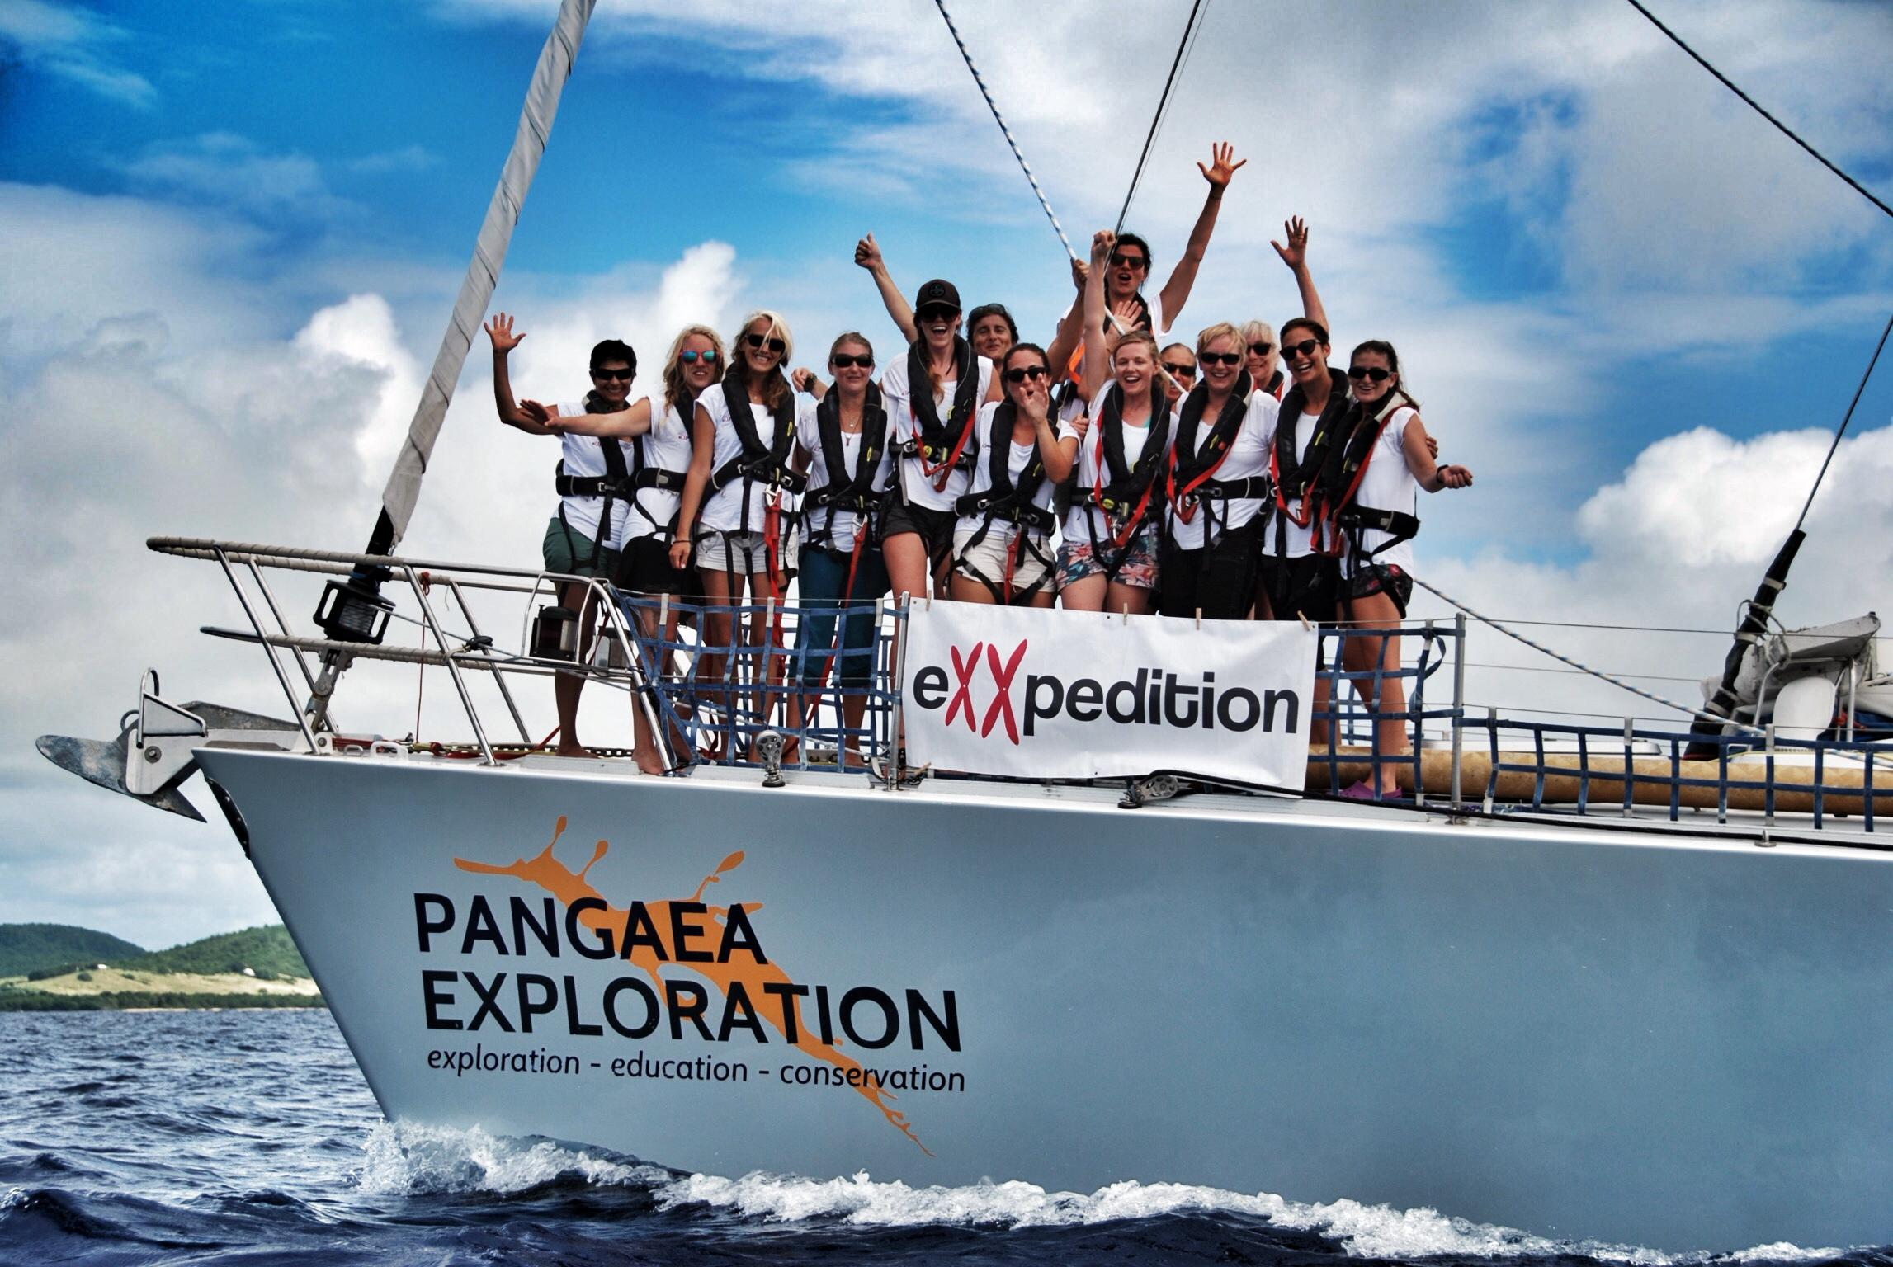
Split over two voyage legs, they will journey for a month over 3,000 nautical miles through the densest ocean plastic accumulation zone on the planet, the North Pacific Gyre - better known as the Great Pacific Garbage Patch.

Aim of North Pacific 2018
- Raise awareness of the devastating impact of single-use plastic and toxics in the world’s oceans
- Champion and contribute to innovative scientific research to tackle the crisis
- Celebrate women in science, leadership and adventure
- Create a community of female changemakers and inspiring global ambassadors to tackle plastic pollution and its environmental and health impacts

Science at Sea
The crew will conduct daily trawls for plastics and pollutants, and collect data for a variety of global datasets and scientific research studies along the way. This data is used to support scientists in the UK, Canada, Switzerland and the USA including conservation organisation Ocean Wise in Canada and the Hawaii Pacific University. Studies range in focus from understanding the impact of plastic pollution on sea turtle environments to microplastics and the impact of toxics carried on plastic, on our bodies.

“Bold, exciting and innovative science into ocean plastic and toxics is at the heart of all eXXpedition voyages. This year, we are seeing a shift in scientific focus. Scientists still want to know how much plastic is out there and where it is, but they also want to know which toxic chemicals are on the surface of it, whether organisms are growing on it and what the impacts might be on wildlife, and on us” says Mission Leader Emily Penn.
An overview of the scientific plan for the voyage is available here.

About eXXpedition
eXXpedition, the British Community Interest Company behind North Pacific 2018, specialises in all-women sailing expeditions. This is the 10th eXXpedition voyage and the first in the North Pacific Gyre. It has the endorsement and support of the UN Environment Clean Seas initiative and Ocean Wise.

Earlier this month, on World Environment Day, Mission Leader and co-Founder of eXXpedition, Emily Penn, was awarded the British Prime Minister's Points of Light award. It recognises outstanding individuals and noted the important work of the eXXpedition voyages in scientific research and ocean advocacy.

The Women Who Make Up The North Pacific Crew
The eXXpedition crew is made up of scientists, students, artists, filmmakers, business women, psychologists, actors, ocean activists and sustainability professionals, and novice as well as experienced sailors.

Whole Voyage
Emily Penn, eXXpedition Co-Founder and Mission Director Instagram: @missemilypenn, Twitter: @emilypenn
Imogen Robinson, Skipper
Anna Strang, First Mate
Jessica MacIntosh, Deckhand

Leg 1 - Hawaii to Vancouver
Sally Earthrowl, Deputy Mission Leader Instagram: @sallyearthrowl
Emily Duncan, Head of Science North Pacific Leg 1
Eleanor Church, filmmaker Instagram: @larkrisepictures, Twitter: @larkrisepacific
Jennifer Russell, filmmaker
Rowan Henthorn, scientist Instagram: @oceanroro
Siri Ostvold, designer Instagram: @siriostvold, Twitter: @siriostvold
Kristine Berg, circular economy communicator Instagram: @kristiiinemarie, Twitter: @kristinemberg
Ana Jarc, environmental engineering student
Michelle Byle, designer Instagram: @michellebyle
Karine Therrien, yoga instructor and teacher

Leg 2 - Vancouver to Seattle
Soraya Abdel-Hadi, eXXpedition Office Manager Instagram: @sorayaleila, Twitter: @sorayaleila
Imogen Napper, Head of Science North Pacific Leg 2 Instagram: @inapps, Twitter: @imogennapper
Beccy Finlayson, TV researcher Instagram: @beccy.fin, Twitter: @beccyfin
Meg Tapp, communications and marketing Instagram: @shutupmegt
Nikkey Dawn, designer Instagram: @nikkeydawn
Victoria Fritz, TV presenter
Sarah Michler, film producer
Ellise Chappell, actress Instagram: @ellisehere
Laura Leiva, scientist Instagram: @lauraleiva11, Twitter @lauraleiva11
Bimadoshka Pucan, PhD candidate

Inspiring Change-Makers
In the four years since the first eXXpedition voyage across the Atlantic, eighty six exceptional women have sailed on missions all over the world creating their own narratives about plastics and toxics, utilising their specific skills and their eXXpedition experience. These eXXpedition Ambassadors have gone on to give inspirational talks, organise plastic-free community projects, implement plastic policies within their organisations, campaign for better legislation, release impactful films and create inspiring ocean plastic artworks.

The Vessel
The eXXpedition crew will be sailing Sea Dragon, a 72ft scientific exploration vessel (owned by Pangaea Exploration) from Oahu, Hawaii to Vancouver, British Columbia (June 25th - July 14th 2018) and then from Vancouver to Seattle (July 21st - July 28th 2018) where the journey will end.

Emily Penn eXXpedition co-Founder: “We are starting our North Pacific voyage with an amazing multidisciplinary crew of inspirational women, as always, but also some fantastic partners. The organisations supporting our journey share our vision of tackling ocean plastic through scientific research and empowering changemakers, and that’s very exciting.We’re looking forward to furthering the science and visibility of ocean plastic and toxics, as well as inspiring our passionate crew to collaborate and take lessons back to their communities."

All costs of the expedition are covered by crew contributions and the generosity of mission sponsors. Many of our sponsors, in particular TOMRA, are involved in pioneering initiatives to tackle plastic pollution around the world. Find out more about them here.
Title Sponsor: TOMRA
Gold Sponsor: The EU Copernicus Marine Service (implemented by Mercator Ocean)
Silver Sponsors: Princess Yachts, Hawk Yachts, Iridium & Global Marine Network
Bronze Sponsors: ​Daedalus Yachts, Y.CO, Finisterre and Port of Vancouver
Partnerships for the expedition include UN Environment Clean Seas​, Parley for the Oceans, 11th Hour Racing, Ocean Wise, Pangaea Explorations & Another World Adventures.

http://exxpedition.com/northpacific/

@exxpedition on Twitter / @exxpedition_ on Instagram /eXXpedition on Facebook (link is www.facebook.com/eXXpeditionCIC/)

Follow news and updates via #eXXpedition

--- Ends ---

FOR MORE INFORMATION:
For more information, interview opportunities or to sign up for event updates for your area, please contact Larissa Clark: E: media@exxpedition.com T: +44 (0)207 097 1734 (a 24/7 UK line) via the Another World Adventures office.

Media Updates & Resources
- Media can access all press releases related to the expedition here
- Dispatches every 5 - 7 days during voyage include film, photos and narrative for media available here
- Images from past voyages are available for media here

Key Media Events and Timeline:

Honolulu Time = 11 hours behind British Summer Time
Vancouver PST = 8 hours behind British Summer Time

HAWAII - PRESS CALL & LEG 1 DEPARTURE
25th June - 0600 to 1000 Honolulu Time - Hawaii Press Call to the Boat where in-person or streamed interviews available with Mission Leader Emily Penn & crew. Location Details on request.
25th June - Mid-Morning Honolulu Time Leg 1 Voyage Departs Kewalo Basin, Honolulu, Hawaii

LEG 1: HAWAII TO VANCOUVER
25th June - 14th July - Crew will be off-shore crossing the North Pacific Gyre. Weekly Dispatches (film, photo, narrative from events at sea) and Press Release updates will be available here.

VANCOUVER PORT CALL
14th July - Arrival Time tbc - Leg 1 ends. Crew arrive to Vancouver and will be moored at False Creek in Downtown Vancouver. Details on request.
14th July - 1500 to 1630 PST Vancouver Press Call to the Boat where in-person or streamed interviews available with Mission Leader Emily Penn & crew. Details on request.
14th July - 1900 to 2130 PST Private event at the Vancouver Aquarium hosted by Port of Vancouver. An evening of talks, film and inspiration from the crew and partners including scientists from Ocean Wise and Port of Vancouver. Media invitations available on request.

LEG 2 > VOYAGE TO SEATTLE VIA VANCOUVER ISLAND
21st July - 1100 to 1200 PST Public Shoreline Clean Up event at Granville Island, Vancouver hosted by Sea Smart, Nada Grocery and eXXpedition
21st July - 1700 PST Leg 2 departs Vancouver for Seattle via Vancouver Island
26th July - 1700 - 1800 PST Victoria. Press Call to the boat where in-person or streamed interviews available with Mission Leader Emily Penn & crew. Details on request.
26th July - 1900 - 2100 PST Event at Patagonia Store, Victoria hosted by Surfrider Foundation evening of talks, film and inspiration from the crew and partners.
28th July - Expedition ends in Seattle.

For media invitations, interviews or any other questions contact: Larissa Clark: E: media@exxpedition.com T: +44 (0)207 097 1734 (a 24/7 UK line) via the Another World Adventures office.
@exxpedition on Twitter / @exxpedition_ on Instagram /eXXpedition on Facebook (link is www.facebook.com/eXXpeditionCIC/) Follow news and updates via #eXXpedition

You can find out more about the history of eXXpedition, why we are focused on women, plastics and toxics, and more information about Sea Dragon on our website, www.eXXpedition.com

