Hype x Feels Collaboration

Hype have teamed up with Feels to find ambassadors for the brand through their App – Launching February 29, 2016 at 5pm. Along with a limited edition Collaboration t shirt, an event will be held at Red Gallery in Shoreditch on April 8th to celebrate the collaboration.
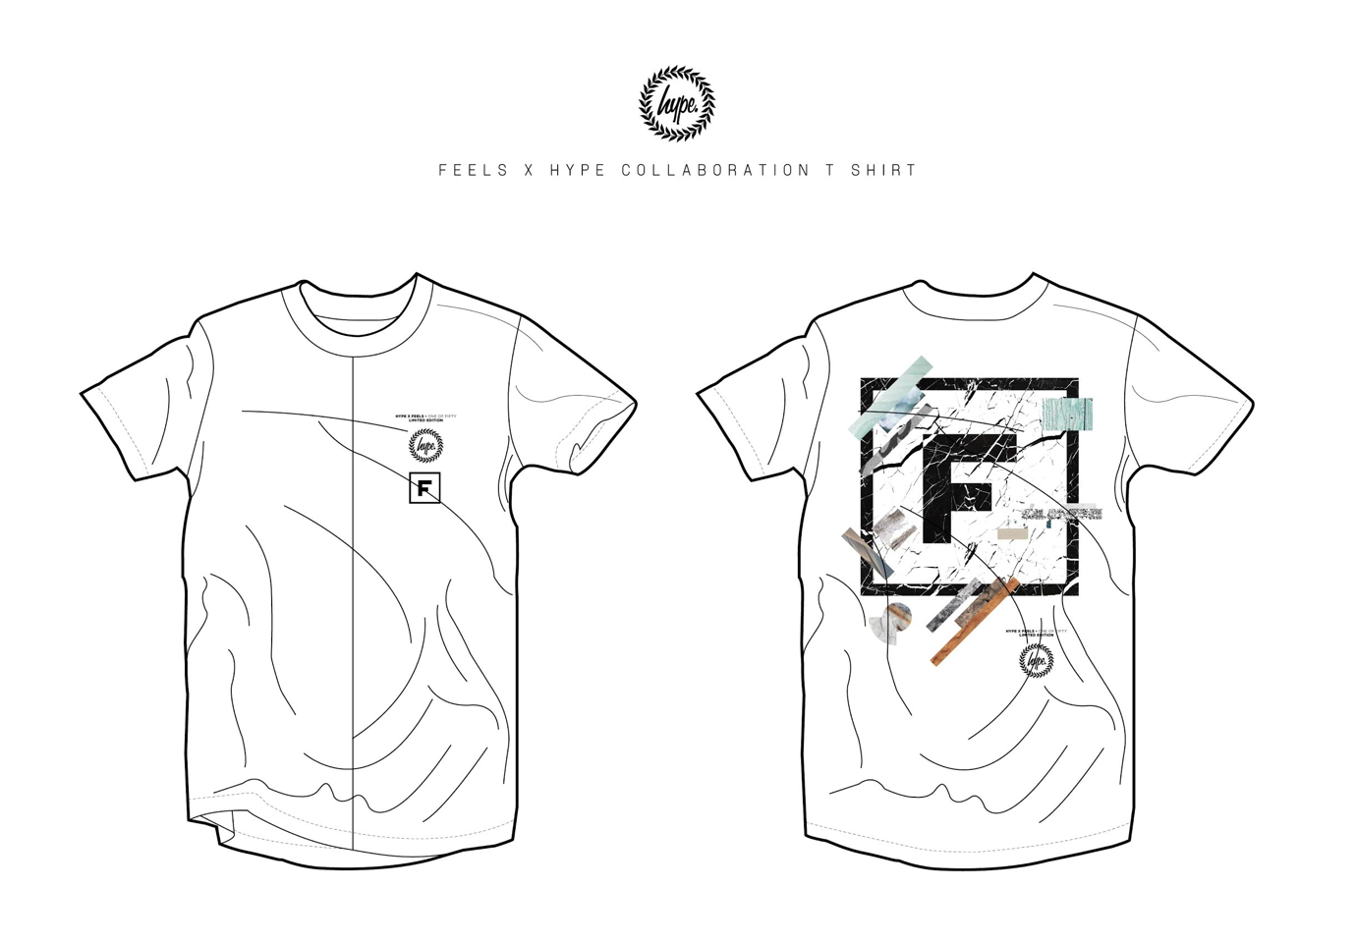
Feels is a photo, video and music-sharing app for lifestyle content. Born out of the Internet term for "feelings" and used to describe something that generates an emotional response, the app was founded by Dawson King in May 2015 and has quickly grown into a global lifestyle platform making waves with iconic brands.

With a reach of more than 6.4 million users weekly, Feels offer brands an exciting new platform for branded lifestyle content and a way to engage with their target audiences. The app has a huge number of influential followers including vloggers, bloggers, actors, musicians and fashionistas, with a combined total reach of more than 110 million worldwide.

Feels has discovered over 80 talent through brand partnerships and agency signings covering TV, brand ambassadors, models, music artists, digital influencers, and has collaborated with renowned brands such as Levi's, John Varvatos, Jeffrey Campbell and most recently globally renowned streetwear label Hype.

The latest update of Feels includes innovative beacon and geofencing technology to extend in-venue experiences and enable in-store specific campaigns for brands looking to drive footfall.

Feels is available to download on the Apple App Store and Google Play.

Press more information:
e. ben@justhype.co.uk
e. dawson@feels.com
