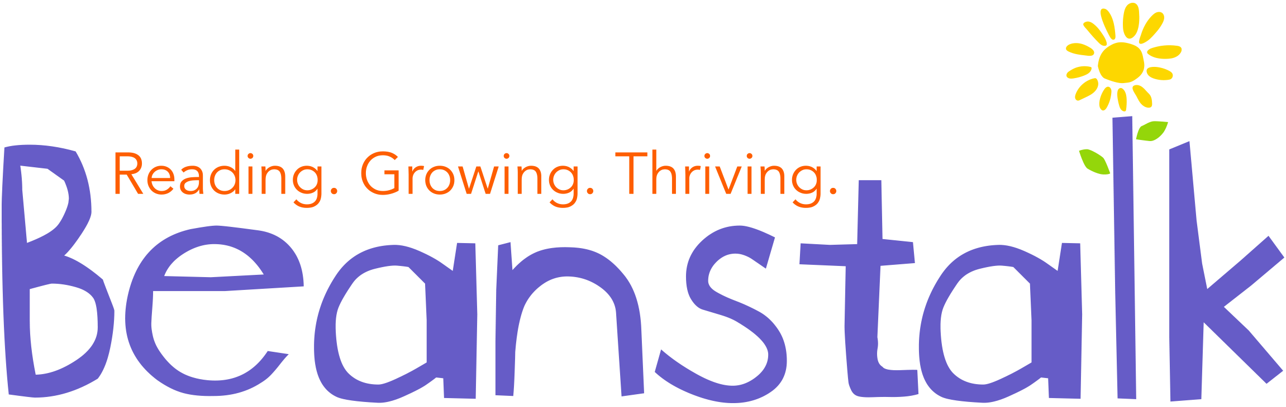

Beanstalk’s Top 40

Lower Key Stage One Titles:
Alborough, Jez - Some Dogs Do
Axtell, David - We’re Going on a Lion Hunt
Campbell, Rod - Dear Zoo
Collins, Ross - There’s a Bear on My Chair
Donaldson, Julia - Wriggle and Roar! (Illustrated by Nick Sharratt)
Gannon, Frann Preston - Dave’s Cave
Goodhart, Pippa - You Choose! (Illustrated by Nick Sharratt)
Murphy, Jill - Peace At Last
Parr, Todd - It’s Okay to be Different
Scheffler, Axel - Axel Scheffler’s Flip Flap Jungle

Upper Key Stage One Titles:
Bromley, Nick - Open Very Carefully (Illustrated by Nicola O'Byrne)
Brown, Ruth - A Dark, Dark Tale
Gravett, Emily - Tidy
Gray, Kes - Oi Frog! (Illustrated by Jim Field)
Hoffman, Mary - The Great Big Book of Families (Illustrated by Ros Asquith)
Jarman, Julia - Class Two at the Zoo
Novak, B.J. - The Book With No Pictures
Robinson, Hilary - Mixed Up Fairy Tales (Illustrated by Nick Sharratt)
Tullet, Hervé - Press Here
Willems, Mo - That Is Not a Good Idea!

Lower Key Stage Two Titles:
Ahlberg, Allan - The Children Who Smelled a Rat (Illustrated by Katharine McEwen)
Ardagh, Philip - Norman the Norman from Normandy (Illustrated by Tom Morgan Jones)
Baker, Jeannie - Window
Browne, Anthony - Little Beauty
Christopher Wormell - Eric... the hero?
Lobel, Arnold - Frog and Toad are Friends
McNaughton, Colin - Once Upon an Ordinary School Day (Illustrated by Satoshi Kitamura)
Robinson, Hilary - The Big Book of Magical Mix-Ups (Illustrated by Nick Sharratt)
Saunders, Matt - There’s No Such Thing as a Snappenpoop (Illustrated by Matt Saunders)
Willis, Jeanne - Lottie Potter Wants an Otter

Upper Key Stage Two Titles:
Ahlberg, Janet and Allan - It Was a Dark and Stormy Night
Browne, Anthony - The Tunnel
French, Vivian - The Covers of My Book Are Too Far Apart (Illustrated by Matt Saunders)
Gaiman, Neil - The Wolves in the Walls (Illustrated by David McKean)
Norriss, Andrew - Archie’s Unbelievably Freaky Week (Illustrated by Hannah Shaw)
Pichon, Liz - The Brilliant World of Tom Gates
Roger, Marie-Sabine - What Are You Playing At?
Rosen, Michael - The Laugh Out Loud Joke Book
Stanton, Andy - You’re a Bad Man, Mr. Gum! (Illustrated by David Tazzyman)
Willis, Jeanne - Tadpole’s Promise (Illustrated by Tony Ross)
To view more information about the books in Beanstalk’s ‘Top 40’ visit the reading resources area of the website: https://www.beanstalkcharity.org.uk/beanstalk-top-40 (this link will be live from 1st May 2018).
For further press information please contact Kate Rumsby kate.rumsby@beanstalkcharity.org.uk 07912 392275, or Sarah Pickstone sarah.pickstone@beanstalkcharity.org.uk, 07815 707701.

