PRESS RELEASE - FOR IMMEDIATE RELEASE

BIDEN BEATING TRUMP ON ALL SOCIAL MEDIA PLATFORMS

London, United Kingdom – 28 October 2020 –
New research from media analytic experts Commetric, shows that Joe Biden is beating Donald Trump on user engagement on all three of the major social media platforms.
On Facebook, Instagram and even Twitter, Biden is shown to be driving more engagement from his followers than his opponent, despite his smaller following.
These findings contradict the conception of Trump as the more social media literate candidate. Trump himself recently stated that he would not have won the 2016 election without Twitter.
Commetric’s research has found that Biden actively generates more engagement from his Twitter followers than Trump does, and is more active on both Facebook and Instagram.
Trump’s massive social media reach on all three social media platforms creates an illusion of popularity, however, Commetric’s analysis of both candidates’ active audiences shows that Biden leads in engagement by a wide margin on all platforms.
Biden’s effective engagement on social media seems to favour his strategy of winning over non-aligned independent voters, a group he is beating both Trump and Hillary Clinton’s records with.
With polling and funding both turning against the President, this new insight on Biden’s success on social media will likely be more unwelcome news to Trump supporters.
In contrast, these results show the Biden campaign has learned from the previous election and worked hard to not be outflanked by their controversial opponent on social media in the way Clinton was.
- ENDS –

Figure 1
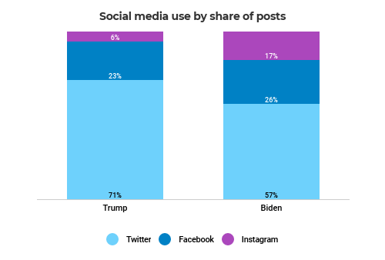
Figure 2
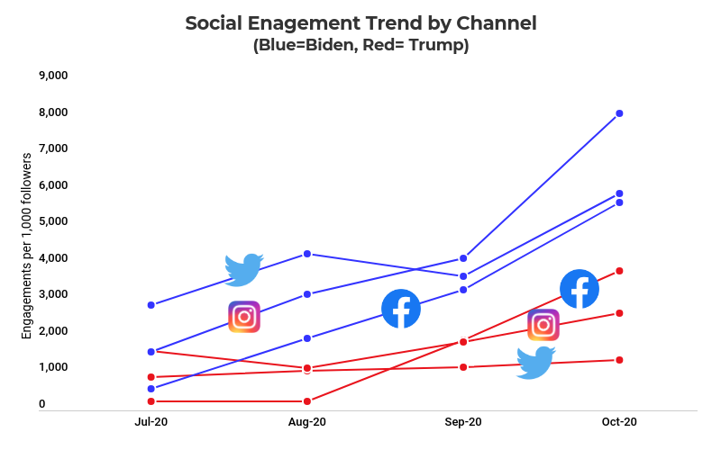

Figure 3
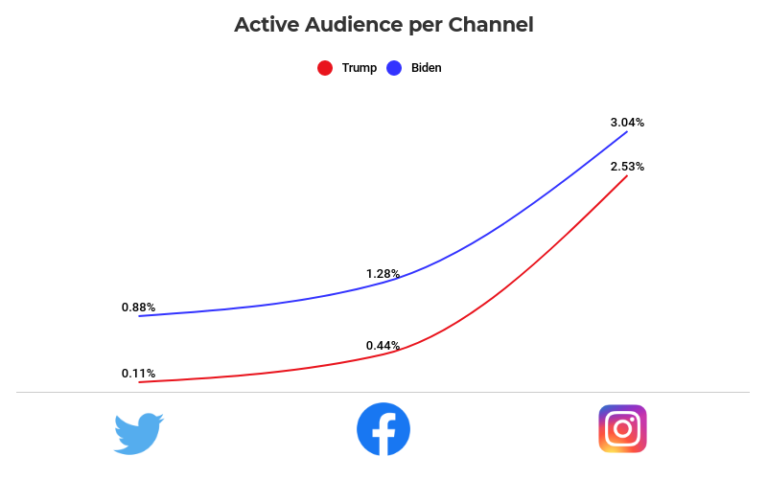

For further information, please contact:
Commetric
Magnus Hakansson, CEO
magnus.hakansson@commetric.com
+44 (0) 845 287 3003

Editor’s Notes

Commetric (www.commetric.com)

Commetric provides advanced media analytics solutions that help organisations manage and measure their corporate reputation. We combine AI and expert human insight to enable clients across industry sectors realise the full potential of their media investments. The firm has won numerous communications industry awards and is a leading AMEC member.

# # #

Commetric • 7-8 Great James Street • London, WC1N 3DF • United Kingdom • Phone +44 (0) 845 287 3003 • www.commetric.com • info@commetric.com

