###FOR IMMEDIATE RELEASE
INNOVATE TAX ANNOUNCES NEW USA BUSINESS VENTURE
UK based indirect tax technology company, Innovate Tax Limited, announces the successful formation of a Limited Liability Company in the United States of America, signifying the achievement of another milestone within its strategic plan for international market growth.
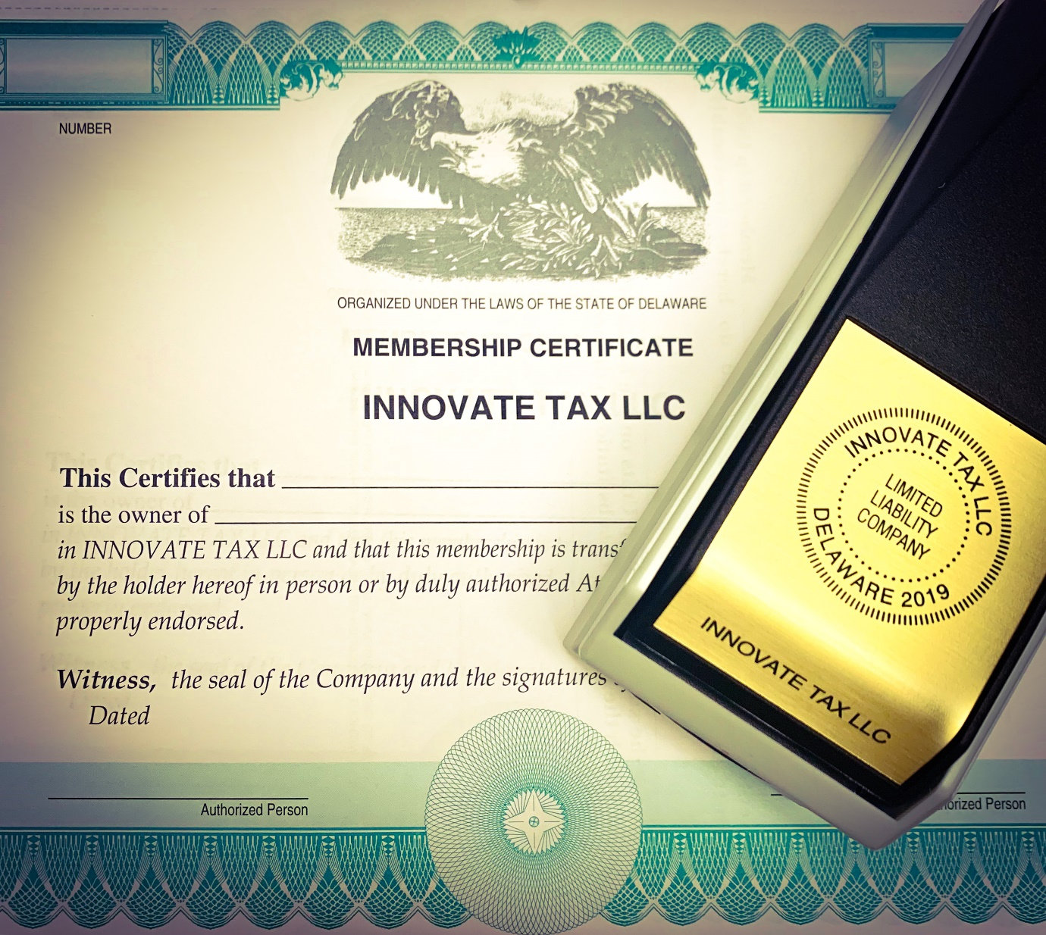
The United States of America has a distinct indirect tax regime where, unlike other countries using a national VAT regime for example, indirect taxes are set on a state-by-state basis. These typically include ‘Sales and Use’ taxes, which are further subject to many intra-state jurisdictions, e.g. counties and towns, which have the authority to dictate and impose their own local rates.
Unsurprisingly, this has long represented a challenge for taxation professionals, who have become mired in a never-ending battle to ensure compliance by staying ahead of current indirect tax rates across the US.

In the past however, whenever such a challenge has emerged, a number of automated technologies have arisen, all purporting to be the saviour of Tax Managers’ woes. Invariably the intrinsic complexities of businesses operating globally means that no singular tax technology offering on the market has ever entirely been able to mitigate each and every challenge.

In the United States, CFOs need to contend with the added complication of doing business abroad. Whilst Sales and Use Tax may be manageable for many businesses that trade solely within the US, those trading internationally find themselves obligated under the specific regulations of each jurisdiction in which they operate, with the majority having very different indirect tax regimes.

More and more businesses that started life or are predominantly based in the US are discovering that their tax technology solutions are somewhat limited; catering well for US Sales and Use tax but not so well for VAT, GST etc.

Nathan Farmer, Commercial Director at Innovate Tax, said of the phenomena:
“US firms are very used to buying tax technology tools, as the Sales & Use Tax regime here is a complicated one to implement and manage effectively.
That’s why we made the strategic decision to form an LLC in the US. Being experts in Oracle EBS & Cloud technology – undoubtedly the most popular ERP systems stateside – as well as third-party Tax Engine integration to any ERP - including the likes of SAP which is often cited as the ERP of choice in the EU – we’re often seen as offering very effective pain relief for US businesses experiencing tax-related symptoms associated with their international interests.”

The familiarity with distinct ERPs and establishing synchronicity between disparate systems is not an easily surmountable challenge. Andrew Bohnet, Managing Director at Innovate Tax, said:
“Think of it this way: say you’ve got a global business with divisions set up in different countries all individually responsible for applying tax treatments and tax reporting. They might all be running different ERP systems, and this becomes a problem if the business is seeking to consolidate its resources. This happens a lot, particularly in cases of business acquisitions where there is a struggle to harmonise inherited systems for tax reporting.”

As far as US based businesses are concerned, the technology behind the tax might be rendered meaningless if, despite being able to link everything together, it is not performing its intended function. According to Farmer, this scenario represents a key factor in making the decision to form with the US:
“We have both the technological and global tax regime expertise, e.g. Sales and Use Tax, GST, VAT etc. This is a powerful differentiator for us that has resulted in an increase of US businesses seeking our products and services to combat the growing demands for indirect tax being felt across the world. It’s a very busy and dynamic time for the company and the market.”

Owing to its well-established reputation for supporting international businesses, the State of Delaware was chosen as the filing location to form Innovate Tax LLC. Speaking about the choice, Farmer remarked:

“We took advice from various parties and decided to incorporate in Delaware because of its outlook towards new US company start-ups.
In terms of day-to-day business operations however, we feel that Atlanta, Georgia, looks like a very good spot for our further local development.
The important thing is that we’re here, we’re accessible and we’re ready to start helping businesses, wherever they might be based in the US.”

###ENDS

NOTES TO EDITOR
ABOUT INNOVATE TAX
Winners of the International Tax Review ‘European Tax Innovator of the Year’ 2016 & 2017.
International Tax Review Magazine’s ‘Newcomer of the Year’ 2017.
Founder and Managing Director, Andrew Bohnet, originally set up the company as eBiz Answers Limited in 2012. Four years later, in 2016, the company changed its trading name to Innovate Tax in order to reflect its development as a Tax Automation Specialist. In 2019 this became its official name, Innovate Tax Limited.
Innovate Tax is a leading provider of automated business technology solutions for the determination of indirect tax.
Integrating with the world’s most popular ERP systems, including Oracle, Innovate Tax’s core solution helps businesses to automatically calculate and apply the correct amounts of indirect tax payable, such as Sales & Use Tax, VAT (Value Added Tax) or GST (Goods and Services Tax), using pre-built rules and logic for over 127 countries.
Innovate Tax has also garnered critical acclaim with the development of its reporting tool LimeLyte®, which provides cutting-edge, real-time indirect tax compliance data.
Innovate Tax also provides a range of ERP agnostic advisory services, including Indirect Tax Solution Review, Tax Centre of Excellence and Tax Technology Consult.
With headquarters in West Sussex, UK, Innovate Tax operates globally, as Innovate Tax LLC in US and Innovate Tax FZE in U.A.E..

COMPANY LEADERSHIP
As the only Oracle ACE for eBTax, Andrew Bohnet – Founder and Managing Director of Innovate Tax – is recognised internationally as the best in his field. Andrew is a world-renowned and prolific speaker on all forms of Indirect Tax. An active participant in global VAT events, Andrew presents worldwide and is the current Chair of the Oracle Tax Management Special Interest Group. He founded Innovate Tax to offer clients an unparalleled service when it comes to a complete tax solution, specialising in VAT globally.
Nathan Farmer, Commercial Director, is the Company lead on all commercial engagements at Innovate Tax. He has created a network of clients and partners all around the world, increasing the market presence and sharing a refreshing tax technology value proposition to every marketplace.

COMPANY CONTACT INFORMATION
For all press and media enquiries, contact Emily Heathorn, Junior Communications Officer:
Email: communications@innovatetax.com
LinkedIn: https://www.linkedin.com/in/emily-heathorn-00685614a/
Phone: +44 1243 860 893
Alternatively, contact Carl Robinson MCIM, Marketing Manager:
Email: crobinson@innovatetax.com
LinkedIn: https://www.linkedin.com/in/carl-robinson-marketer/
Phone: +44 1243 860 893
COMPANY PROFILES
Website: www.innovatetax.com
LinkedIn: www.linkedin.com/company/innovate-tax/
Twitter: twitter.com/innovatetax
Innovate Tax Limited, a limited company registered in England and Wales under company number 08119496 whose registered and main trading address is Suite 101 Heath Place, Ash Grove, Bognor Regis, West Sussex PO22 9SL, United Kingdom.

