FOR IMMEDIATE RELEASE Contact: Elizabeth Batalla,
The Institute for Achievement and Excellence.
Phone: +44 (0) 790 326 7990
Email: elizabeth.batalla@achievementandexcellence.com

The Modern Woman’s Roadmap to Achieving Success
in a Gender Bias Society: New Book Release
Create What You Want Personally. Get What Matters Professionally.

[LONDON - UK, March, 2022—] Elizabeth Batalla’s new book - Level Up to Move Up: The Three Forces in Achieving Excellence, discusses what women must do to become unstoppable in any area of their life. It’s a systematic framework that will guide them through what it takes to show up at their best in everything they do. It provides simple insights, tips and techniques women can implement immediately.
This book will support women in achieving their professional and personal transformation goals to secure leadership roles and business opportunities.

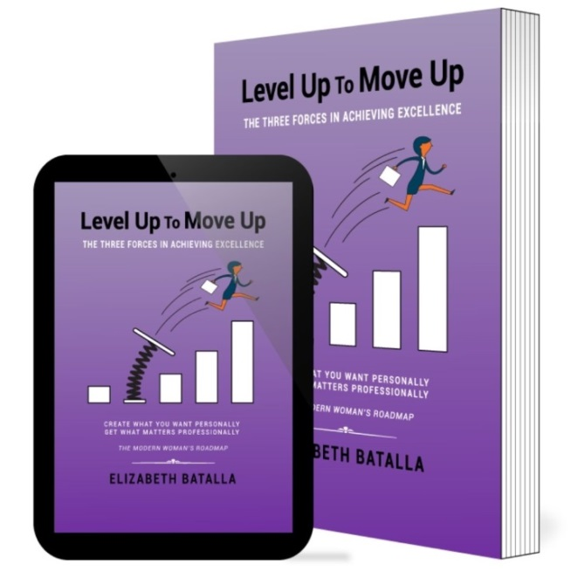
- 65% of women say lack of confidence is the reason women are underrepresented in management roles.

- Women make up just 15% of executive-team membership, and more than a third of companies have no women at all on their executive teams.

- Companies with broadly diverse leadership teams were 45% more likely to report growth in market share.

The book is based on The Three Forces in Achieving Excellence:

- Identity - your identity is your unique stamp on the world and the core of who you are as a person. It will determine the direction you go in life and how easily the doors of opportunity will open for you.

- Connection - your connection to yourself, others, and things are an innate part of who you are as a human being and will impact every aspect of your persona. It will determine how much others support you in your journey through life.

- Status- your status influences your standard of living and will impact your quality of life. It will determine the options you have available to you, the resources you can access, and the lifestyle you can experience.

“Women are still under-represented in many industries and find it challenging to get the sponsorship they need for their professional advancement. Women also continue to lead on household tasks and childcare duties, often unnoticed.” says Elizabeth Batalla, Founder of The Institute for Achievement and Excellence.

Look inside the Book

Elizabeth Batalla is the founder of The Institute for Achievement and Excellence and who created and developed The Three forces in Achieving Excellence. She spent 30+ years in the corporate world and continues to mentor other women along the way. She publishes a blog with strategic tips and advice to achieve success and creates online masterclass programs that are crucial for taking a holistic approach to achieving personal and professional fulfilment.

If you would like more information or to interview the author, please call Elizabeth Batalla at +44 (0) 790 326 7990, email elizabeth.batalla@achievementandexcellence.com or connect on LinkedIn

Additional Links
Past interviews: https://courses.achievementandexcellence.com/p/interview-profile
Website: https://achievementandexcellence.com
Book link: https://books2read.com/leveluptomoveup
LinkedIn profile: https://www.linkedin.com/in/elizabethbatalla

Social links
Youtube: https://www.youtube.com/channel/UCn08Yx5bKaRIwf0Im5P69dg?sub_confirmation=1
LinkedIn:
https://www.linkedin.com/company/the-institute-for-achievement-and-excellence
FaceBook:
https://www.facebook.com/instituteforachievementandexcellence
Instagram:
https://www.instagram.com/achievementandexcellence
Twitter:
https://twitter.com/InstExcellence
Pinterest:
https://www.pinterest.co.uk/AchievementandExcellence
Blog:
https://courses.achievementandexcellence.com/blog
The Three Forces in Achieving Excellence Article:
https://achievementandexcellence.com/the-three-forces-in-achieving-excellence

