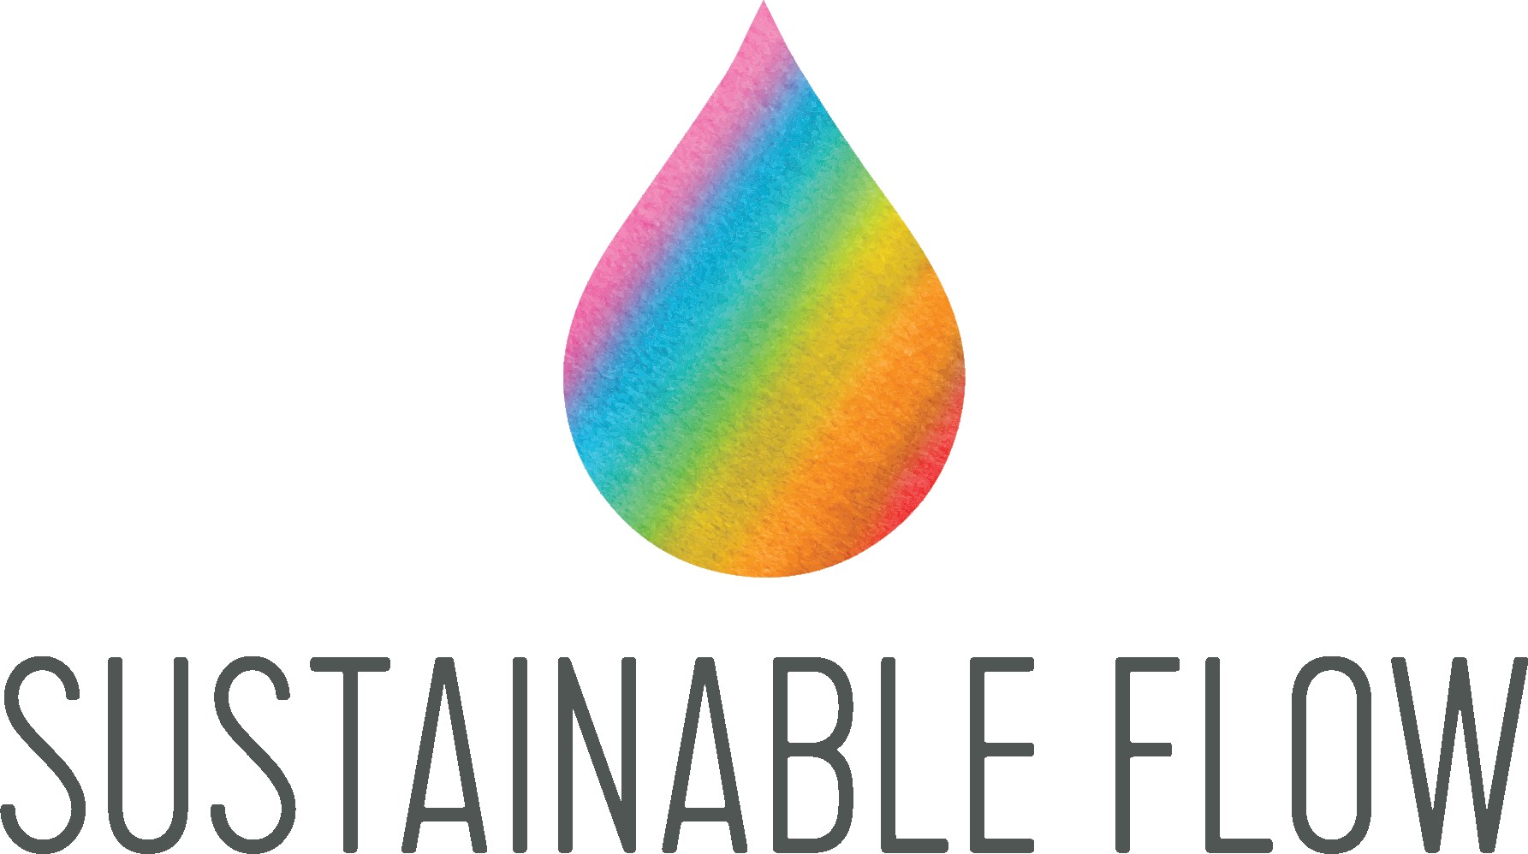

Innovative Magnetic Device Reduces Car Emissions by 70% and Provides Fuel Cost Savings of up to 15%.

October 18th - LONDON: Sustainable Flow , a conscious technology company, has launched an innovative magnetic car device that significantly reduces harmful carbon emissions by up to 70%, helping motorists to cut their fuel bills by up to 10% and shrink their carbon footprint.
Nat Rich, a former model and DJ, started Sustainable Flow over three and a half years ago. Two years later, her father David Richardson and good friend Miguel came on board to support her efforts in creating a platform of eco-friendly systems that enable everyone to reduce their carbon emissions and contribute to saving the planet.

Simple and user-friendly technologies such as this one, have the potential to bring London much closer to complying with its commitments to the Paris Climate Agreement, whilst also helping their users to save money. They also provide an example of how individuals can start to make a big difference in reducing the capital’s carbon emissions, without having to make any major changes to their lifestyle. This is a subject that the company is currently trying to raise awareness for.

Nat commented: “People think it’s just down to the government to save the day, but that’s just passing the buck to someone else. It’s a group effort and there are more humans than there are government officials, so when you do the math it’s pretty obvious who needs to take action to make a change”.

The Engine Performance Optimiser gives drivers petrol performance with diesel economy.

Independent tests conducted by Dr Abhishek Asana and supported by Halfords of Eyre Street, Sheffield reported car emission reductions of up to 69.9 per cent and fuel savings of up to 10 per cent.

Every car tested, including the oldest of 9 years, was positively impacted by the magnets, with significant fuel savings and emission reductions recorded for each.

How does it work?

Three powerful hi-tech ceramic magnets are installed onto the air, coolant and fuel lines of the engine, which improves fuel combustion by lowering fuel viscosity and breaking it into smaller particles. This works by increasing the net surface area of the fuel, so the molecules burn from the surface, optimising the combustion of the fuel and substantially lowering exhaust emissions.

A more in-depth explanation of the science behind the technology can be found here.

Sustainable Flow are the first, and only company, to bring this patented technology to the UK.

Sustainable Flow are hoping to provide the answer to the air pollution epidemic gripping UK cities, especially in London where the levels of pollution have triggered a ‘high alert’.

The UK government is under mounting pressure to do more to tackle climate change and meet it’s 2023-2027 emissions reductions targets, which they are currently on course to miss.

To meet their 80% target for 2050, the UK will have to reduce carbon emissions by at least 3% a year, starting now.

Sustainable Flow want to help drivers and companies to save money on fuel, whilst also doing their bit to tackle climate change.

Sadiq Khan’s T-charge, which aims to discourage older cars from driving in central London by introducing a charge of £11.50, comes into force on October 23th. This presents a difficult, and expensive predicament for a number of businesses with fleets, and taxi operators.

Sustainable Flow’s Engine Performance Optimiser provides a solution for this, helping older cars to reduce their carbon emissions and pass the T charge checker, making them exempt from the charge and empowering them to do their part in reducing air pollution in London.

The device is suitable for all car models and can be fitted at over 3,500 local garages across the UK.

Once fitted, the device does not require servicing so there’s no need to book in for regular checks; drivers can simply install it and forget about it. The magnets come with a lifetime guarantee and do not affect or void their car manufacturer’s warranty.

The patented, ISO rated technology is extremely adaptable and has numerous uses, across motor, marine and rail vehicles, properties, pools, spas and ponds, and agriculture.

The technology, covered by the internationally accepted Magnuson-Moss Warranty Act, has an impressive global reach and has been making waves in the USA, with the US government, US Armed Forces, and companies including Panasonic, Siemens, Disney, Hilton Hotels all using the technology across various platforms.

Sustainable Flow have the exclusive distribution rights to sell the patented high- tech ceramic monopolar magnetic technology.

Find out more:

www.sustainableflow.org

Contact:

David Richardson
david@sustainableflow.org

PR & Press Enquiries:
Amelia Henderson
ah@semetrical.com

